Tejaswini SE

1RVU22BSC105

**Lab - 2 Domain: E-Commerce Website (used HTML, CSS and JavaScript)**

1. Clicking on the different heading will take you to respective sections.

2.All the categories have three sub menus.

3.In product categories there are four menus and has different shoes collection with prices.

4.This page uses html, java script and CSS.

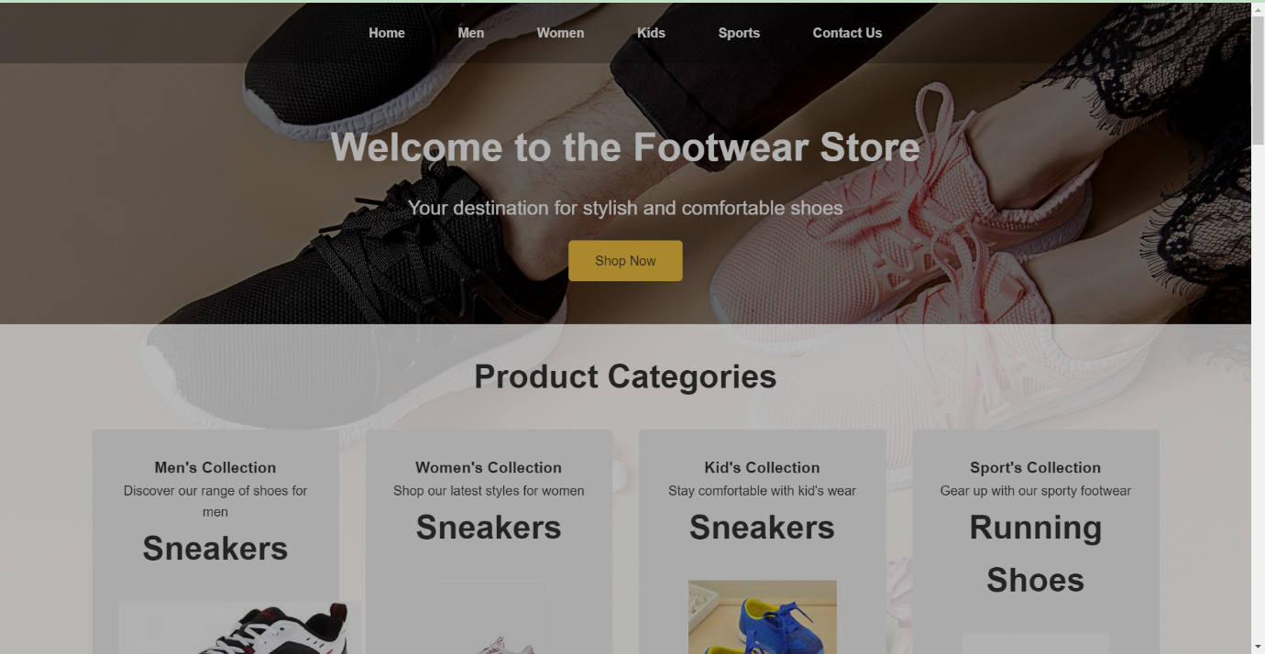

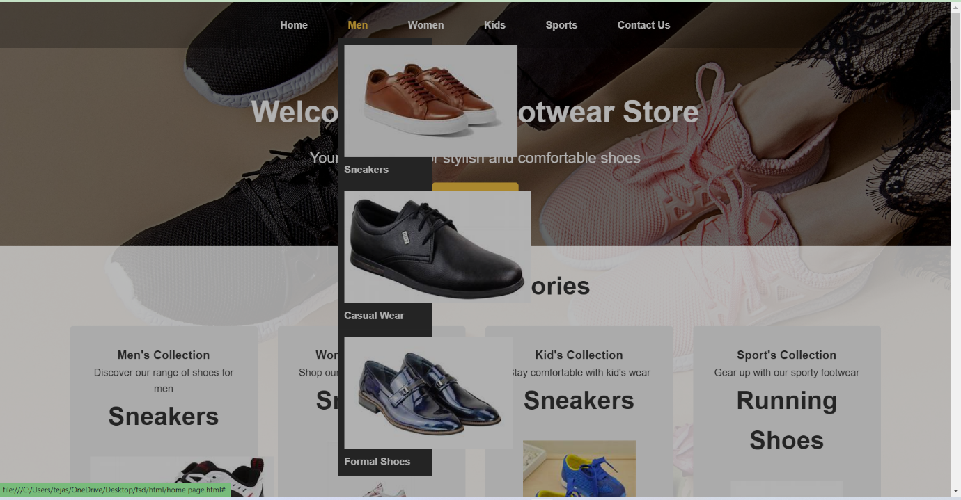

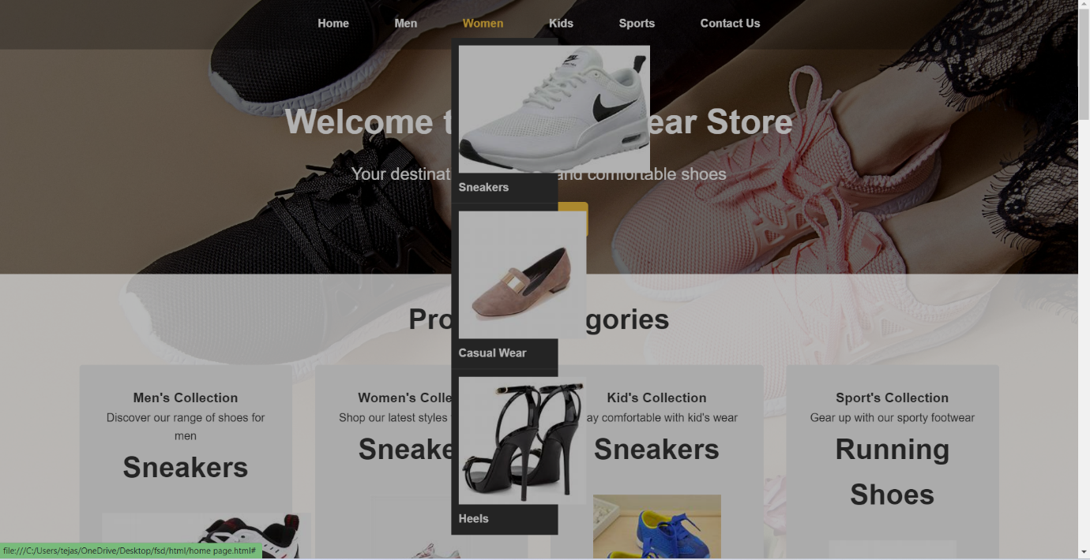

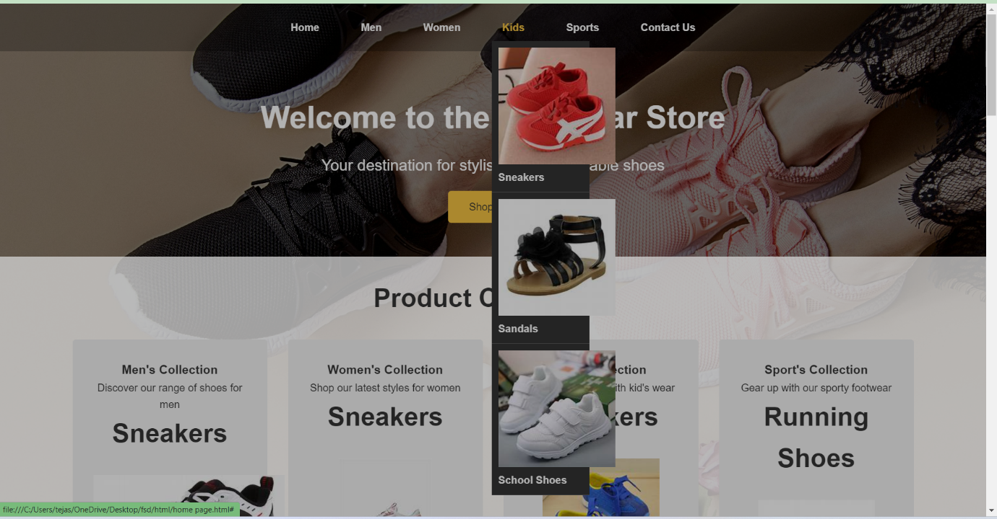

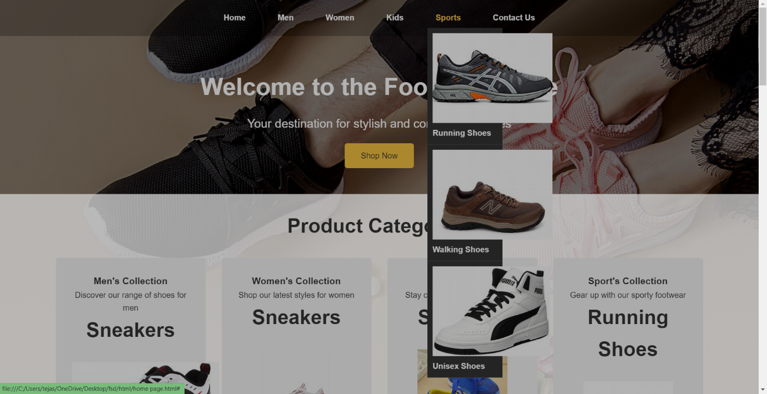

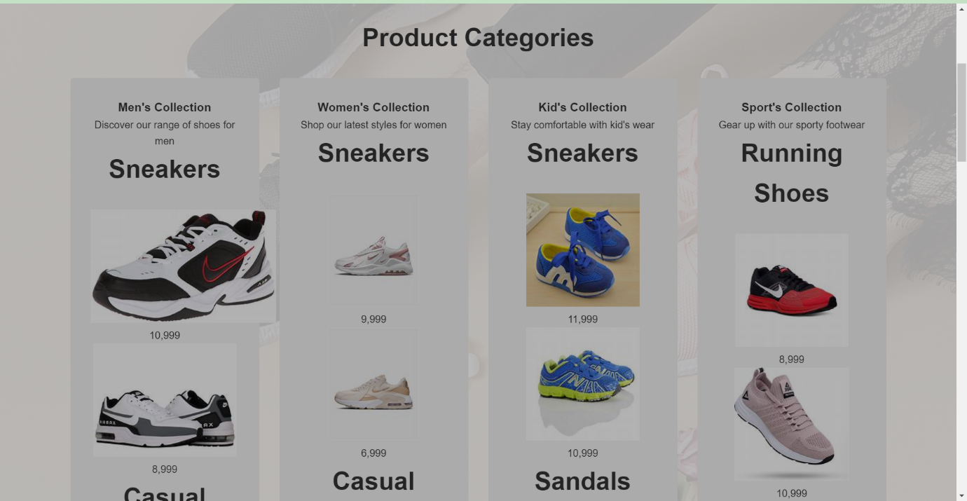

**Code:**

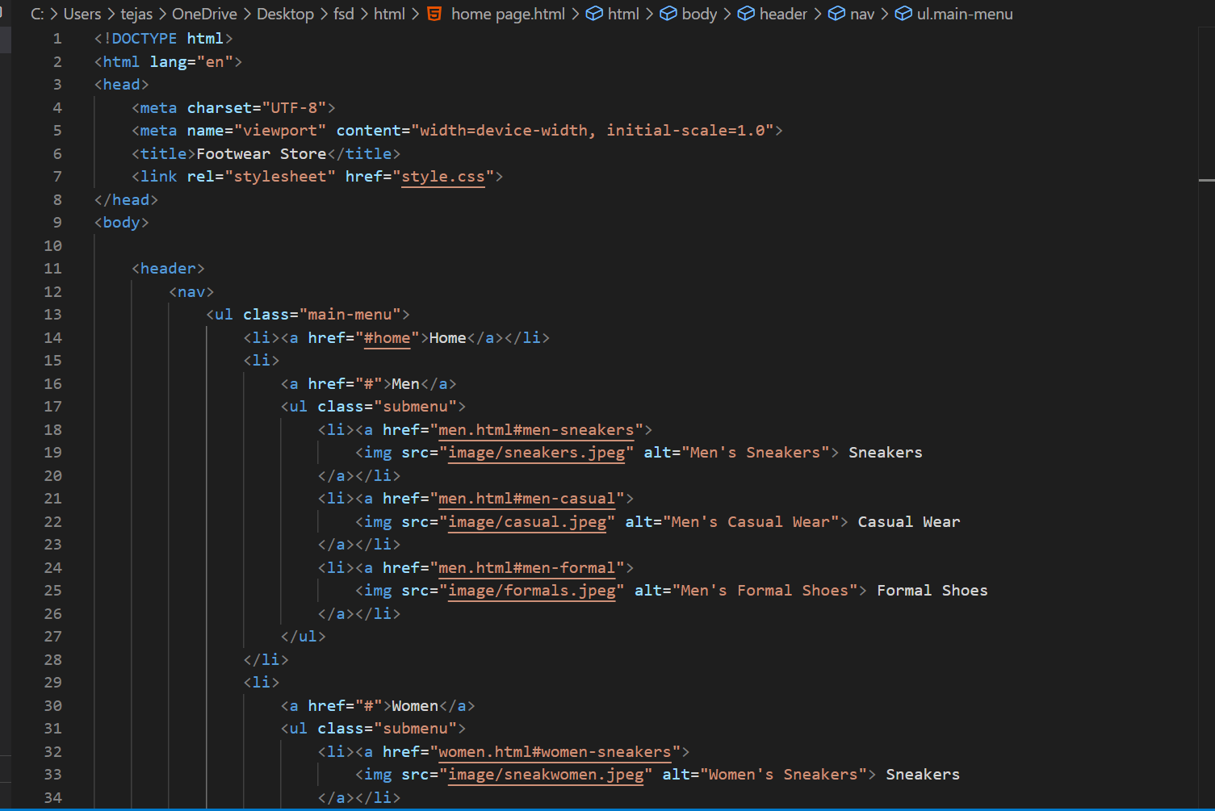

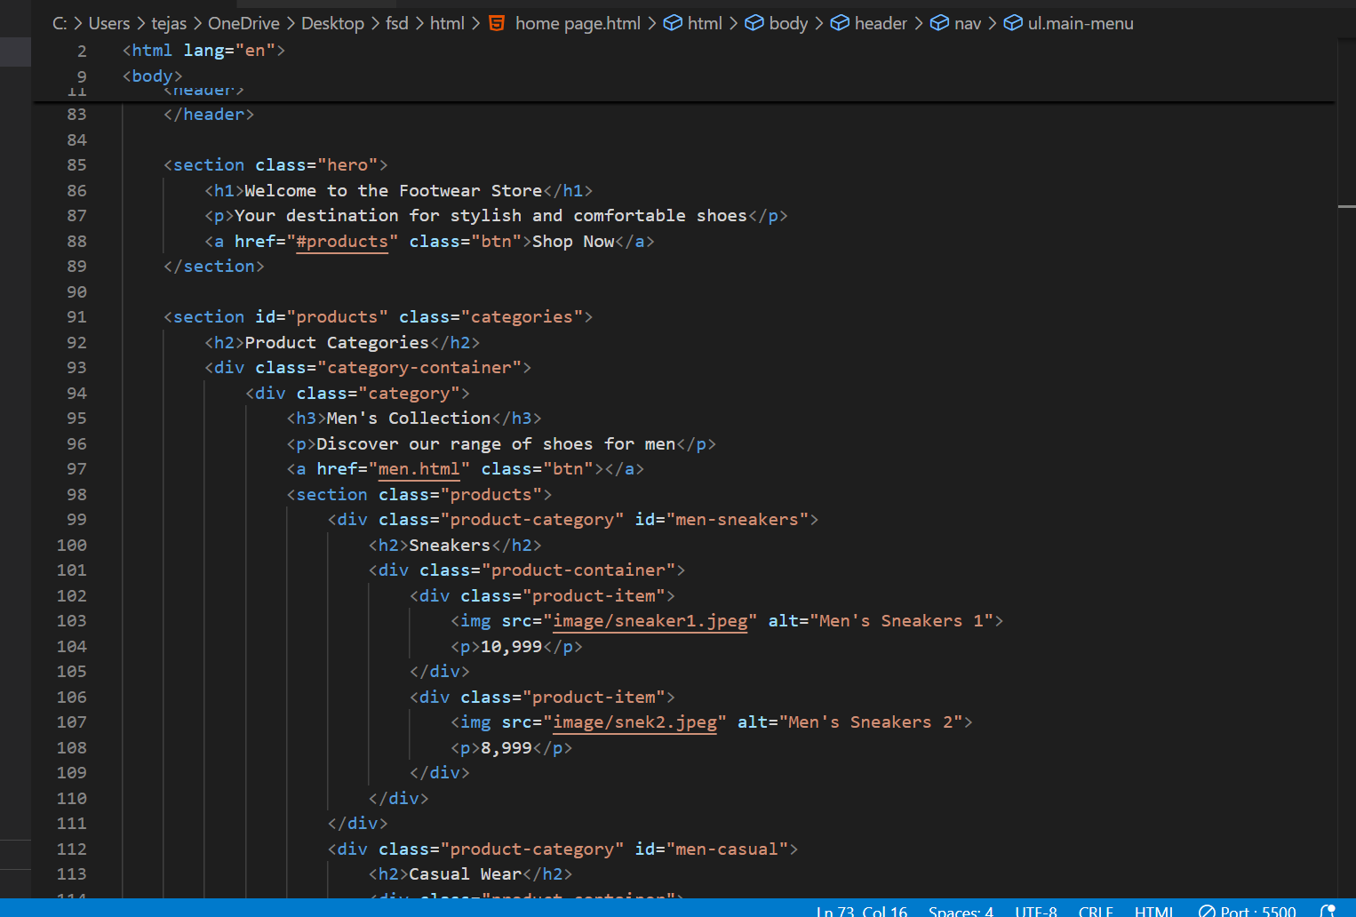

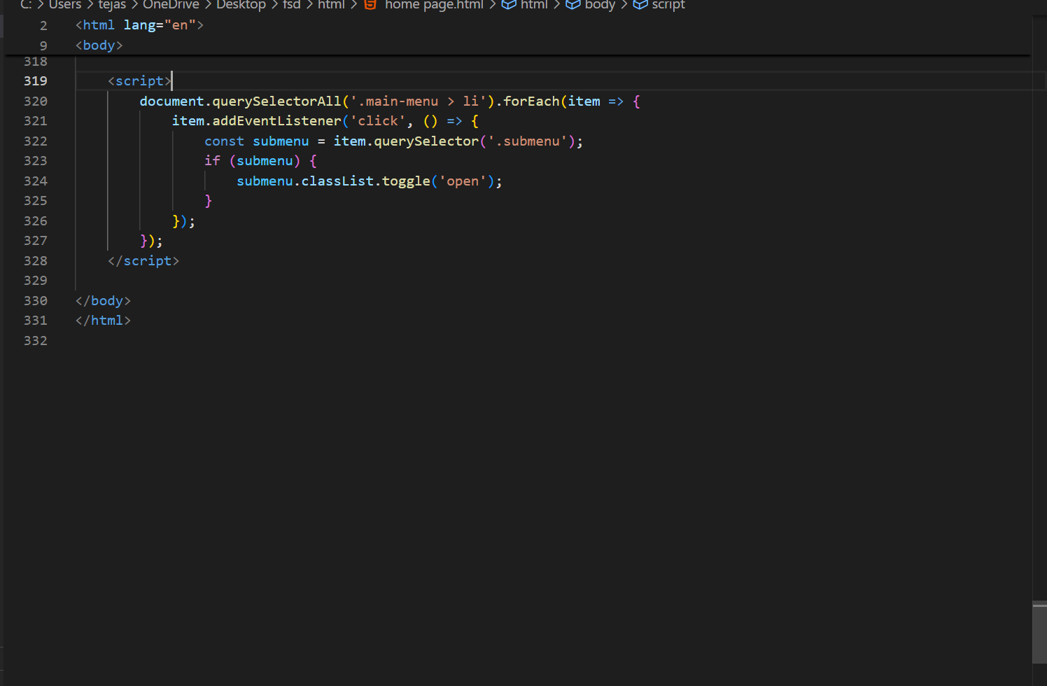

CSS: 